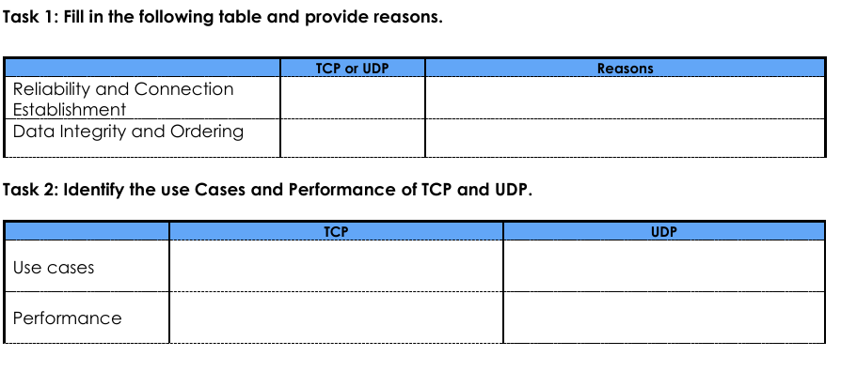
Faster then tcp but less reliable
Reliable for data transmission and communication
Video streaming
Web browsing
TCP detects errors and try to transfer again
TCP
TCP
Tcp ensure data sent is received in order.

